Date : 17/03/2023

Secure Kloud Technologies Limited
No.37 & 38, ASV Ramana Towers,
5th Floor, Venkat Narayana Road,
T-Nagar,
Chennai – 600 017.
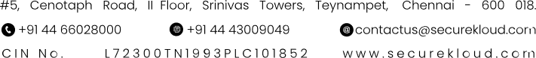
Sub: Letter of Undertaking & Confirmation
---

I, Subbulakshmi M son/daughter/wife of Muralidharan N residing at 5/313,Periyar Nagar,Harur. employed with Secure Kloud Technologies Limited (formerly known as 8K Miles Software Services Limited) having its registered office at No.37 & 38, ASV Ramana Towers, 5th Floor, Venkat Narayana Road, T-Nagar, Chennai – 600 017. (hereinafter referred as Company) do hereby assure and confirm as under:

- I was employed as Software Engineer- Trainee with the Company since 19th July 2021.
- I have voluntarily resigned from the services of the Company in order to pursue better career optionsI have offered to resign from the services of the Company vide my email dated 17/03/2023.
- I understand and confirm that all information relating to the Company, its customers, employees, business, competition, data, records, technical information, intellectual property rights, financial position, marketing strategy which I have gained access to by virtue of my employment with the Company shall be deemed as Confidential Information and I shall not disclose to any third party without prior written permission of the Company even after leaving the services of the Company.
- I assure and undertake that for a period of 24 months from the date of being relieved from the Services of the Company, I shall not solicit or accept any offer of employment from any competitor, customer of the Company. I further assure that I shall not commence any new business activity on my own or with any other person/s for a period of 24 months from the date of being relieved from the Services of the Company, which directly or indirectly competes with the business of the Company.
- I further assure and undertake that I shall not directly or indirectly through any third party solicit the services of any person who is an employee of the Company by any offer of employment or contract of engagement or otherwise, for a period of 24 months from the date of being relieved from the services of the Company.
- I agree and confirm that the undertakings provided herein are fair and reasonable. I shall not challenge or dispute any of the undertakings provided herein under any reason whatsoever and further confirm that I was employed by the Company was based on such assurances given by me from time to time.
- * By virtue of being employed as Associate with the Company, I understand I am in the Senior Management of the Company based on which I am privy to a lot of Confidential Information, data, statistics, strategy pertaining to the Company, its employees, customers and competitors. I confirm I have fiduciary responsibilities to the Company and assure that during the term of my employment with the Company, I have not indulged in any activity that :
- Conflicts with the interest of the Company and/or
- Brings disrepute to the Company in any manner whatsoever and/or
- Results in breach of my fiduciary responsibilities towards the Company
( * applicable for designations Director and above)

- I agree that the Company is entitled to initiate civil and criminal Legal actions against me in case I commit any breach of my undertakings herein including seeking monetary compensation for any business and/or reputational loss, damage, opportunity cost, caused to the Company.
- I further confirm that notwithstanding the right to seek monetary damages, the Company shall also be entitled to appropriate injunctive orders or such other order of Specific Performance against any possible or threatened breach of my undertaking set forth herein.
- I understand that this undertaking is given by me as a part of completing my relieving formalities with the Company and the relieving letter to be issued by the Company shall be subject to the Undertaking and Confirmation being true and accurate without any breach thereof.
- This Letter of Undertaking and Confirmation shall be subject to the Laws of India and within the jurisdiction of appropriate Courts in Chennai.

Signature of the Associate | 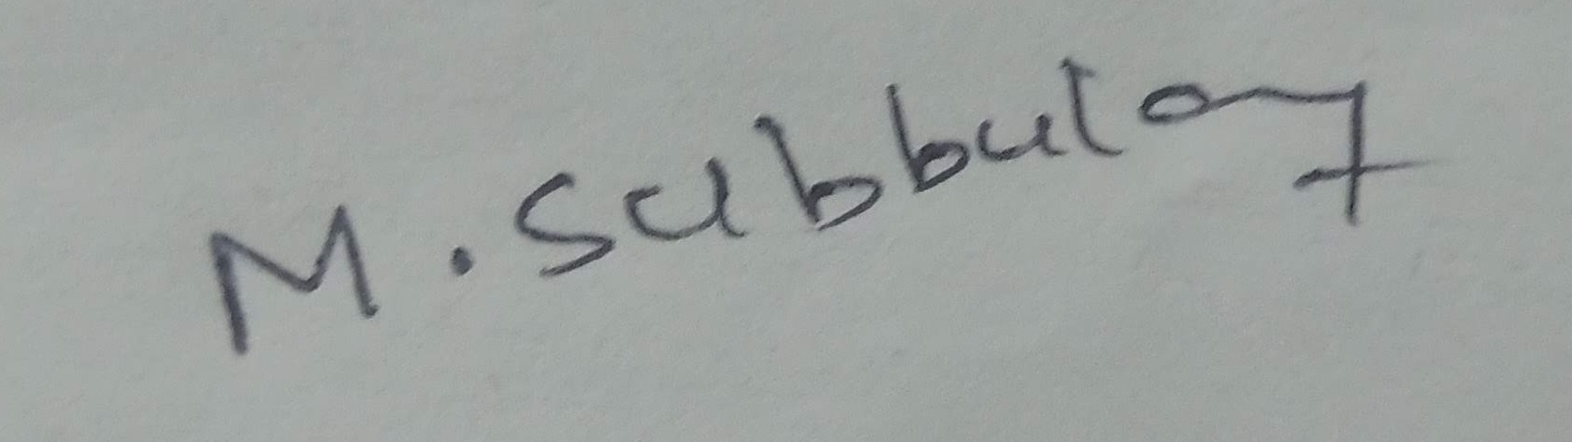
Name of the Associate | Subbulakshmi M
Date | 17/03/2023
Place | Chennai

